ABSTRACT PREPARATION INSTRUCTIONS FOR THE 57TH JAPANESE PEPTIDE SYMPOSIUM

Taro Tottori¹, Hanako Inaba¹, and Jiro Sakyu ²

¹ Graduate School of Engineering, Tottori University, 4-101 Koyama-Minami, Tottori 680-8552, Japan, ² Graduate School of Agricultural Sciences, Tottori University, Koyama-Minami 4-101, Tottori 680-8553, Japan.

Abstracts must be uploaded onto the website of “the 57th Japanese Peptide Symposium” in PDF file using this template. If you simply type into this template there should be no need to worry about the page layout, font size and/or spacing. However, some critical details are given below:
Maximum length of abstract is one A4 sheet (not US letter) with 25 mm margins on top, left and right sides and 30 mm for the bottom. Use exact 18 pt spacing throughout the document and Times New Roman font with 12 pt. Title has to be bolded with uppercase letters and left-adjusted. Leave one line with exact 18 pt spacing between title and author list. In the case of authors from multiple institutions, superscripts, 1, 2, 3,… after the author names should be used. Take 25 mm left margin for the title and the name of the author. Leave one line with exact 18 pt spacing between the author list and the affiliations. Underline the name of the presenting author. Leave one line with exact 18 pt spacing between the affiliations and the text. Indent each paragraph 1.25 cm. Figures and appropriate key references [1,2] may be included if desired within the one-page limit. Citations should be in-line, as a number enclosed in square brackets. The corresponding reference list (in numerical order) begins below the end of the text.
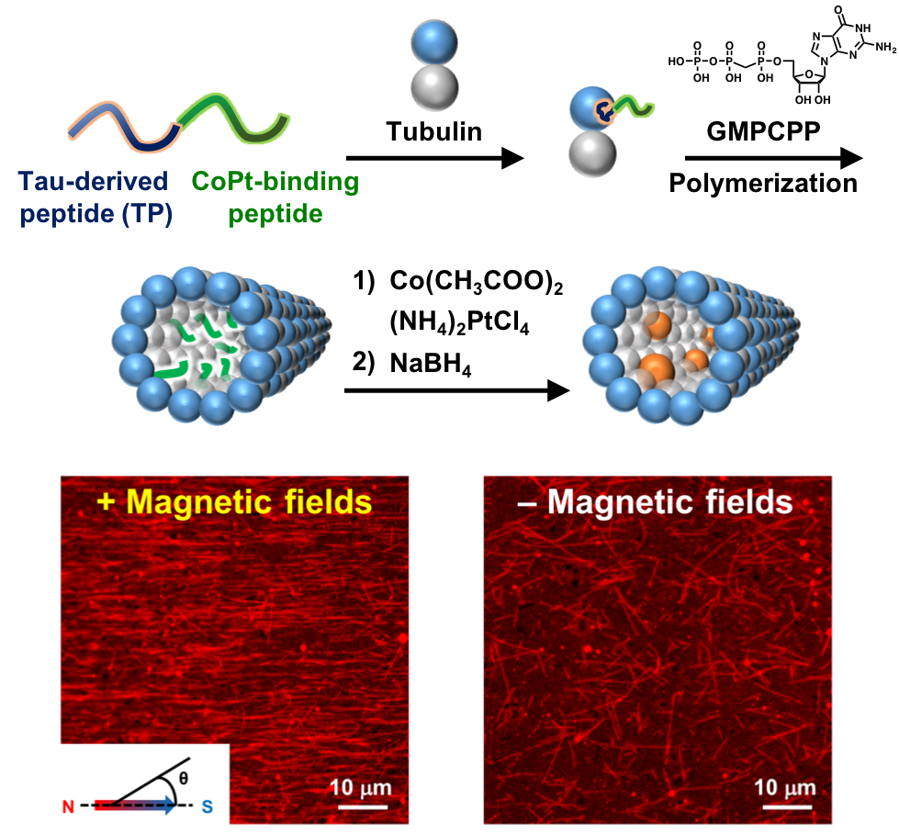
Fig. 1. Encapsulation of CoPt nanoparticles inside microtubules by using a peptide connecting Tau-derived peptide (TP) and CoPt-binding peptide. CLSM images of the CoPt nanoparticle-encapsulated microtubules with and without magnetic fields.
A one-page abstract written in English has to be submitted before the deadline of abstract (September 1st, 2020).

[1] H. Inaba, T. Yamamoto, T. Iwasaki, A. M. R. Kabir, A. Kakugo, K. Sada, K. Matsuura, Chem. Commun., 2019, 55, 9072.
[2] H. Inaba, M. Yamada, M. R. Rashid, A. M. R. Kabir, A. Kakugo, K. Sada, K. Matsuura, Nano Lett., 2020, 20, 5251.

