C. Elegans Insulin-like Peptides, INS-35 and INS-7, Change Their Secretion Polarity in Larval Diapause

Yohei Matsunaga¹, Yoko Honda², Shuji Honda², Takashi Iwasaki¹,
Hiroshi Qadota³, Guy M. Benian³, and Tsuyoshi Kawano¹

¹The United Graduate School of Agriculture, Tottori University, ²Genomics for Longevity and Health, Tokyo Metropolitan Institute of Gerontology, ³Departoment of Pathology, Emory University School of Medicine
e-mail: kawano@muses.tottori-u.ac.jp

The insulin/IGF-I signaling pathway regulates larval diapause as well as adult lifespan in C. elegans. The insulin-like peptides, INS-35 and INS-7, are mainly produced in the intestinal epithelial cells and suppress larval diapause to maintain developmental growth, cooperatively. These peptides are secreted into the body cavity in normal development. However, in larval diapause, they are secreted into the intestinal canal and degraded. When the worms return to developmental growth, these peptides are secreted into the body cavity again.

Keywords: C. elegans, larval diapause, insulin-like peptides, intestine,
secretion polarity

Introduction
The insulin/IGF-I signaling (IIS) pathway regulates larval diapause as well as adult lifespan in C. elegans [1]. So far, 40 insulin-like peptides (ILPs) have been identified and some of them regulate the IIS pathway through the sole insulin/IGF-I receptor ortholog, DAF-2. These ILPs have been classified into type-α, -β and -γ according to the number and the position of disulphide bonds [2]. In our previous study, we have demonstrated that one of the type-α ILPs, INS-35, decreases its transcriptional level in the space where aging decelerates and that knockdown of ins-35 extends adult lifespan [3]. In addition, our RNAi screening for the type-α genes revealed that only knockdown of ins-35 resulted in statistically significant promotion of larval diapause. However, function of INS-35 in larval diapause remains elusive.
Here, we show unambiguous function of INS-35 in larval diapause and its cellular expression pattern. We also show that INS-7 (type-β) [4] regulates larval diapause in cooperation with INS-35 and that its cellular expression pattern is quite similar to that of INS-35.

Results and Discussion
We first verified involvement of INS-35 in larval diapause using an ins-35(ok3297) mutant. This mutant has a 664 bp deletion including the second exon,
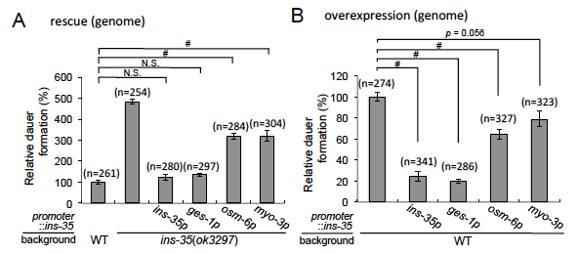

Fig. 1. Relative percentages of dauer formation in each ins-35 mutant in the presence of dauer inducing-pheromone compared with wild type are shown. (A) Dauaer formation of ins-35(ok3297) and its rescued mutants by each promoter. (B) Dauaer formation of mutants expressing ins-35 by each promoter. Data are expressed as the mean ± S.E. # p < 0.05; N.S.: Not Significant. Multiple comparisons between groups were made using Dunnett’s test.

indicating that ins-35(ok3297) is a loss of function mutant. As shown in Figure 1A, the mutant showed significant promotion of larval diapause (dauer formation) in the presence of dauer-inducing pheromone [5], indicating that the normal function of INS-35 is to suppress larval diapause. In addition, to investigate where INS-35 functions most critically, we expressed ins-35 gene in a tissue-specific manner in ins-35(ok3297) and wild-type animals. In the presence of dauer-inducing pheromone, ins-35 expressed in the intestine (ges-1p::ins-35) completely rescued the phenotype of ins-35(ok3297), the same as ins-35 expressed by its native promoter. In contrast, ins-35 expressed in chemosensory neurons (osm-6p::ins-35) or muscle cells (myo-3p::ins-35) partially rescued the phenotype of ins-35(ok3297). In the overexpression experiments (Figure 1B), ins-35 expressed in the intestine extensively suppressed dauer formation, the same as ins-35 expressed by its native promoter. In contrast, ins-35 expressed in chemosensory neurons or muscle cells suppressed dauer formation with some degrees. These results suggest that INS-35 functions most critically in the intestine to suppress larval diapause (dauer formation).
Next, to examine the cellular expression pattern of ins-35, we generated a transgenic animal expressing INS-35 fused to VENUS, a variant of yellow fluorescent protein, driven by the ins-35 promoter region. In normal development (L1~L4 stages), INS-35::VENUS fluorescence was observed in the intestine, chemosensory neurons and coelomocytes [6], which are scavenger cells that constitutively endocytose material secreted from the body cavity (Figure 2A). At the diapause stage (dauer arrest), the fluorescence was observed in the intestine and coelomocytes (Figure 2B). Taken together, ins-35 is expressed in the intestine and chemosensory neurons at L1 to L4 stages, and in the intestine at dauer arrest.
Moreover, the fluorescence gradually decreased in diapause (Figure 3A), suggesting that INS-35::VENUS is degraded in the intestinal canal. To investigate possible degradation of INS-35, we next performed Western blot analysis using ins-35p::ins-35::venus (Figure 3B). In ins-35p::ins-35::venus expressing animals, an anti-GFP monoclonal antibody clearly detected INS-35::VENUS (approximately 42

Fig. 2. Expression patterns of ins-35p::INS-35::VENSU. (A) Expression patterns in normal development (L1~L4). Solid arrowheads indicate amphid neurons. Asterisks indicate the coelomocytes. Arrows indicate the intestinal tissue. The scale bar is 50 µm. (B) Details expression patterns in dauer arrest. Arrows indicate the intestinal valves. Hollow arrowheads indicate the anus. Asterisks indicate coelomocytes. The scale bar is 50 µm.

kDa) in lanes corresponding to adults and individuals in diapause. Significantly, a band of approximately 31 kDa, the size expected for VENUS, became visible in the
lane corresponding to day 1 of dauer arrest, and at day 14, this band was even more prominent, whereas the INS-35::VENUS band was faint. These results support gradual degradation of INS-35 in the intestinal canal during diapause.
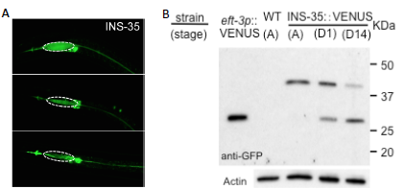

Fig. 3. Degradation of INS-35::VENUS during dauer arrest. (A) Fluorescence of INS-35::VENUS in the intestinal lumen at day 1, day 7 and day 14 of dauers. The scale bar is 50 µm. (B) Western blot analysis using anti-GFP and anti-actin antibodies of extracts of ins-35p::ins-35::venus expressing worms: A, adult stage; D1, dauer stage at day 1; D14, dauer stage at day 14.

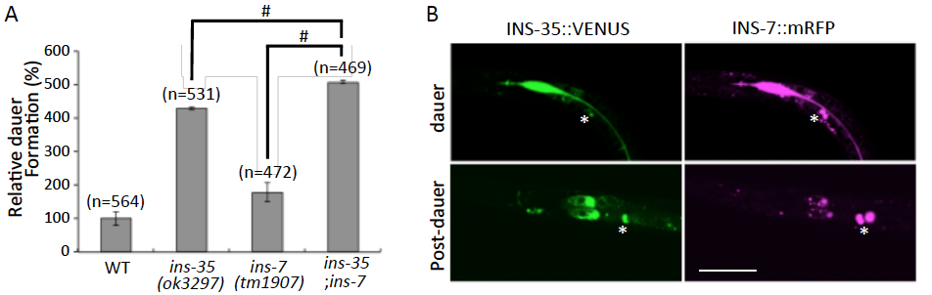

Fig. 4. INS-35 and INS-7 modulate dauer arrest cooperatively. (A) Relative percentages of dauer formation in each ins-35, ins-7 and double mutants in the presence of dauer inducing-pheromone compared with wild type are shown. Data are expressed as the mean ± S.E. # p < 0.05. Multiple comparisons between groups were made using Dunnett’s test. (B) Fluorescence of INS-35::VENUS and INS-7::mRFP in the intestinal lumen at dauer and post-dauer. Asterisks indicate coelomocytes. The scale bar is 50 µm.

To investigate whether other ILPs are produced in the intestine and accumulated into the intestinal canal in diapause, we checked INS-6, -7 and DAF-28, which are reported to suppress larval diapause. Among them, INS-7 showed both suppression of dauer formation and expression in the intestine as INS-35. As shown in Figure 4A, an ins-7(tm1907) mutant showed promotion of dauer formation in the presence of dauer-inducing pheromone. Moreover, an ins-7;ins-35 double mutant showed stronger promotion than that of each single mutant, indicating that INS-35 and INS-7 suppress larval diapause cooperatively. As shown in Figure 4B, INS-7::mRFP accumulated in the intestinal canal at dauer arrest, the same as INS-35::VENUS. Furthermore, both tagged proteins were extensively detected in coelomocytes at post-dauer, indicating these proteins are secreted into the body cavity again.
In summary, we clarified function of INS-35 and INS-7 in larval diapause and their expression patterns in normal development and diapause. These peptides are produced in the intestine and cooperatively regulate larval diapause. These peptides change their secretion polarity between body cavity and intestinal canal. In the intestinal canal, these peptides are degraded during larval diapause. This study will provide new insights into endocrinology.

References
- Murphy, C.T., Hu, P.J. (2013) WormBook, Dec 26, 1-43.
- Pierce S.B., Costa, M., Wisotzkey, R., Devadhar, S., Homburger, S.A., Buchman, A.R., Ferguson, K.C., Heller, J., Platt, D.M., Pasquinelli, A.A., Liu, L.X., Doberstein, S.K., Ruvkun, G. (2001) Genes & Dev., 15, 672-686.
- Honda, Y., Higashibata, A., Matsunaga, Y., Yonezawa, Y., Kawano, T., Higashitani, A., Kuriyama, K., Shimazu, T., Tanaka, M., Szewczyk, N.J., Ishiok, N., Honda, S. (2012) Sci. Rep., 2, doi: 10.1038/srep00487.
- Murphy, C.T., McCarroll, S.A., Bargmann, C.I., Fraser, A., Kamath, R.S., Ahringer, J., Li, H., Kenyon, C. (2003) Nature, 424, 277-283.
- Kawano, T., Kataoka, N., Abe, S., Ohtani, M., Honda, Y., Honda, S., Kimura, Y. (2005) Biosci. Biotechnol. Biochem., 67, 2678-2682
- Fares, H., Greenwald, I. (2001) Genetics, 159, 133-145.

