ABSTRACT PREPARATION INSTRUCTIONS FOR THE 58TH JAPANESE PEPTIDE SYMPOSIUM

Taro Toyaku¹, Hanako Hachioji¹, and Jiro Ochanomizu ²

¹School of Pharmacy, Tokyo University of Pharmacy and Life Sciences, Hachioji, Tokyo 192-0392, Japan, ²Institute of Biomaterials and Bioengineering, Tokyo Medical and Dental University, Chiyoda-ku, Tokyo 101-0062, Japan

Abstracts must be uploaded onto the website of “the 58th Japanese Peptide Symposium” in PDF file using this template. If you simply type into this template there should be no need to worry about the page layout, font size and/or spacing. However, some critical details are given below:
Maximum length of abstract is one A4 sheet (not US letter) with 25 mm margins on top, left and right sides and 30 mm for the bottom. Use exact 18 pt spacing throughout the document and Times New Roman font with 12 pt. Title has to be bolded with uppercase letters and left-adjusted. Leave one line with exact 18 pt spacing between title and author list. In the case of authors from multiple institutions, superscripts, 1, 2, 3,… after the author names should be used. Take 25 mm left margin for the title and the name of the author. Leave one line with exact 18 pt spacing between the author list and the affiliations. Underline the name of the presenting author. Leave one line with exact 18 pt spacing between the affiliations and the text. Indent each paragraph 1.25 cm. Figures and appropriate key references [1,2] may be included if desired within the one-page limit. Citations should be in-line, as a number enclosed in square brackets. The corresponding reference list (in numerical order) begins below the end of the text.
A one-page abstract written in English has to be submitted before the deadline of abstract (August 17th, 2021).
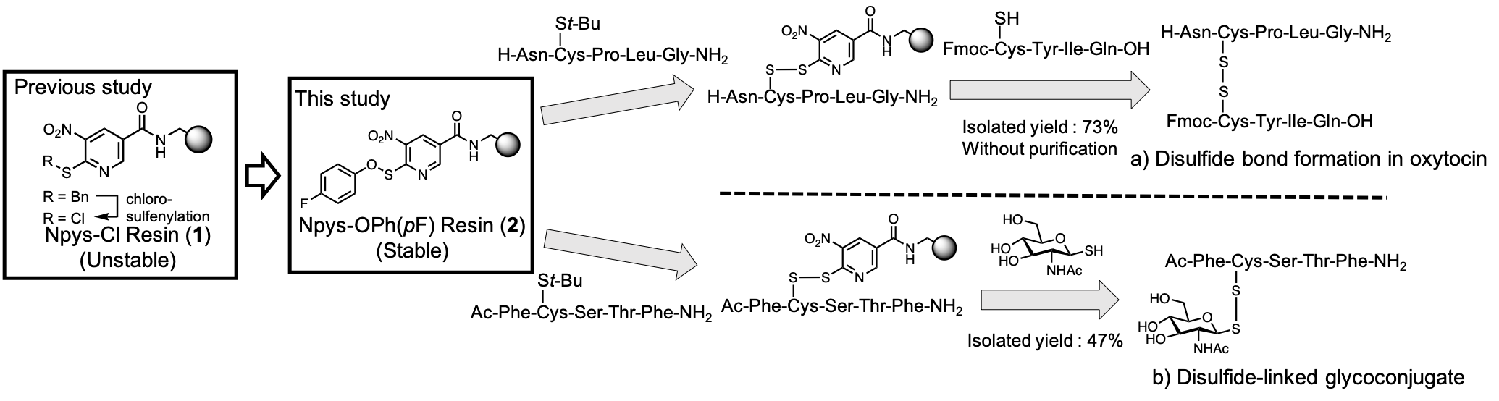

[1] Taguchi, A., Kobayashi, K., Cui, Y., Takayama, K., Taniguchi, A., Hayashi, Y. (2020) J. Org. Chem., 85, 1495-1503.
[2] Cui, Y., Taguchi, A., Kobayashi, K., Shida, H., Takayama, K., Taniguchi, A., Hayashi, Y. (2020) Org. Biomol. Chem., 18, 7094-7097.

