|  |  |
| --- | --- |
| **Synthesis and Conformational Analysis of Cyclic Amino Acids that Promote Distinct Helical Folding of α/β-Peptides**  Woo Hyung Lee, Philjae Kang, Moon-Gun Choi and Soo Hyuk Choi* |  |

*Department of Chemistry, Yonsei University, 50 yonsei-ro, Seodaemun-gu, Seoul, 120-749, Republic of Korea*

E-mail: [sh-choi@yonsei.ac.kr](mailto:sh-choi@yonsei.ac.kr)

The study of oligomers that contain alternative α- and β-amino acid residues is a fascinating topic to explore synthetic foldamers that adopt helical secondary structure. These foldamers that show conformational propensities such as helix, sheet, and turn play pivotal roles in living systems. What is more, the conformationally restricted β-amino acid residues give the ability to maintain conformational stability with hydrogen bonding interaction, including the intrinsic attributes of β-amino acid residues like willingness to form well-defined secondary structure as few as four residues, the richer possible derivatives than α-amino acid, and stability toward enzymatic degradation. In addition, the foldamers with heterogeneous backbones have the several advantages. First of all, the large number of candidate foldamer backbones is possible. Secondly, the heterogeneity of backbones makes it easy to generate foldamer sets. Finally, they have feasible strategies that should facilitate independent and complementary functions between α- and β-amino acid.

The alternating α/β-Peptides can display distinct helical folding patterns with respect to the direction of carbonyl groups. One is a backward orientation of the carbonyl bonds that have the aligned direction of macrodipole, and the other is an alternating orientation of the carbonyl bonds that have the reduced overall macrodipole. A number of studies of the former have already been accomplished by Gellman group such as a hypothesis of interconverting helical conformations between 11-helix and 14/15-helix containing *trans*-ACPC residues. On the other hand, few researches of the latter were achieved until now. Accordingly, we have focused on the topic of the study of the alternating α/β-Peptides that promote distinct helical folding like the latter. In this work, we synthesized the β-lactam which is a precursor to β-amino acid residues by using [2+2] cycloaddition with chlorosulfonyl isocyanate (CSI) and 1,5-cyclooctadiene. We also synthesized several α/β peptides in a 1:1 alternating pattern by using canonical synthetic methods and peptide coupling strategies. Furthermore, we studied structural information of our foldamers with respect to helicity with 1D NMR study and X-ray crystallography analysis.

**Representative Figures**

 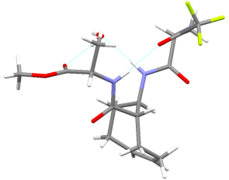 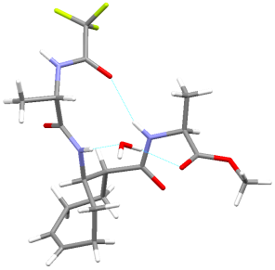

**References**

1. W. S. Horne and S. H. Gellman, “Foldamer with Heterogeneous Backbones*”,* *Acc. Chem. Res.*, Vol. 41, No. 10, (2008), 1399-1408

2. S. H. Choi, I. A. Guzei, L. C. Spencer, and S. H. Gellman, “Crystallographic Characterization of Helical Secondary Structure in α/β-Peptides with 1:1 Residue Alternation*”,* *J. Am. Chem. Soc.*, 130, (2008), 6544-6550