Title

Name Name¹, Name Name², and Name Name¹

¹Department of Medicinal Chemistry, University, Sakai, Hyogo 607-8412, Japan, ²Department of Chemistry, Graduate School of Medical Science, University of Medicine, Uji, Kyoto 606-0823, Japan
e-mail: example@gmail.com

Abstract abstract abstract abstract abstract abstract abstract abstract. Abstract abstract abstract abstract abstract abstract abstract abstract. Abstract abstract abstract abstract abstract abstract abstract abstract. Abstract abstract abstract abstract abstract abstract abstract abstract. Abstract abstract abstract abstract abstract abstract abstract abstract.

Keywords: peptides, peptides, peptides,peptides

Introduction
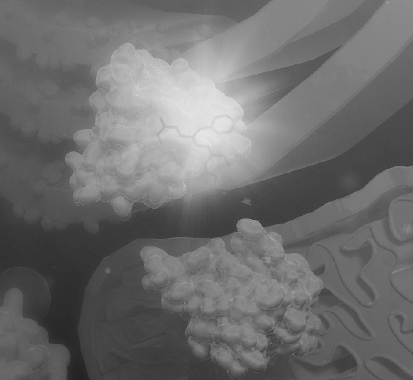
Introduction introduction introduction introduction introduction……….

Fig. 1. The structure of previously reported inhibitors.

Results and Discussion
Results and discussion, Results and discussion [1]. Results and discussion, Results and discussion [2]………

Scheme 1. Synthetic route for RI-modified inhibitors.

Table 1. IC₅₀ values of RI-modified inhibitors.

References
- Name, K., Name, K., Name, S. (2003) J. Chem., 68, 1129-1135.
- Name, T., Name, C., Name, H., Name, S., Name, H., Name, K., Name, K. (2010) Bioorg. Chem., 18, 2000-2020.
- Name, C., Name, T., Name, S., Name, G., Name, H., Name, K, Name, K., Name, Y., Name, K. (2014) Bioorg. Chem., 22, 2499-2510.

